**PURPOSE:**

To outline the process of volunteer dog walking to ensure the safety of the canines being walked and the minimization of contagious disease spread.

**Requirements:**

Dog walking volunteers are to review this process and execute dog walking in this way to assist HSC in keeping animals, staff, the public, and volunteers safe as well as minimize the spread of contagious diseases.

**Equipment**

Minimally, a dog walking volunteer should have the following when preparing to walk:

* HSC Dog Walker fanny pack (includes: small treats, slip lead, poop bags, small squeaky toy)
* Slip Lead/Leash/Harness
* Dog Walker’s cell phone
* 2-Way Radio
* Kennel key

Harnesses/Leashes can be found in Operations Laundry Room. If you cannot find the size you need, please work with a staff member who can assist you. When using a harness, remember that the leash must be clipped to both the front ring of the harness as well as the martingale collar ring to ensure they are unable to slip out.

HSC Dog Walker fanny packs and 2-Way Radios can be found in the Volunteer Program Manager’s office. They should be checked in and out at each shift, using the log sheet on the desk in the office.

You will need to use a key to unlock the kennel doors. There are 4 kennel keys located inside the lock box in front of the Volunteer Program Manager’s office. The code to the box is 157. When you take a key replace it with your car keys within the lockbox. This will help you remember to return the kennel key later. If no keys are available you can ask a staff member for assistance.

**Key and fanny pack log for dog walkers**

When you arrive and grab your items. You need to sign the dog walking key and fanny pack log. This informs us when you were here and which items you are responsible for. You can see the log below.



**Public Dog Adoption Area**

Dogs in the public dog adoption area are typically medically & behaviorally cleared and available for adoption but may be unavailable or not walk-approved for a variety of circumstances. Dogs that are **not** walk-approved will be noted on their kennel cards in the Dog Adoption Binder and are **not** to be walked by volunteers under any circumstances.

Review the Dog Walking Binder located in the food prep area and **always** make sure you log your walks on the Dog Walking Reference Sheet with your name, cell phone number, dog’s name, and AM or PM to indicate which shift. The binder includes cage card signage for information regarding the dog’s disposition, dog skills, and any medical conditions that you should be aware of before removing the dog for a walk. (See picture and example below)

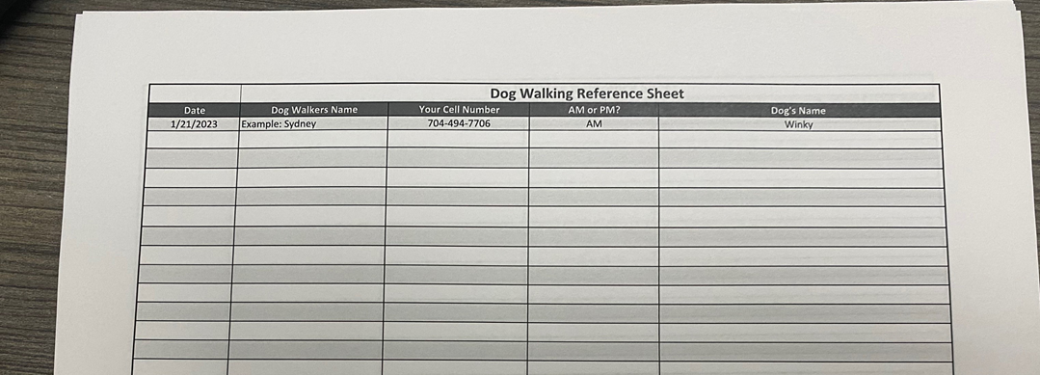

Once you choose which walk-approved dog to walk and have logged your information on the Dog Reference Sheet, you will use your kennel key to unlock the suite door and can leave unlocked while out on your walk with the dog. Once you come back from your walk and safely return the dog to their suite, you will lock the door with the key. **Make sure to log your interaction on the dog’s enrichment log. (**Enrichment log example below**) You can also write any additional notes about the dog that may be helpful to staff and dog walkers on the back of their kennel card with a sharpie (ie. Knows sit and paw, loves tennis balls, shy at first, but quickly warms out once outside, big cuddler, etc).**

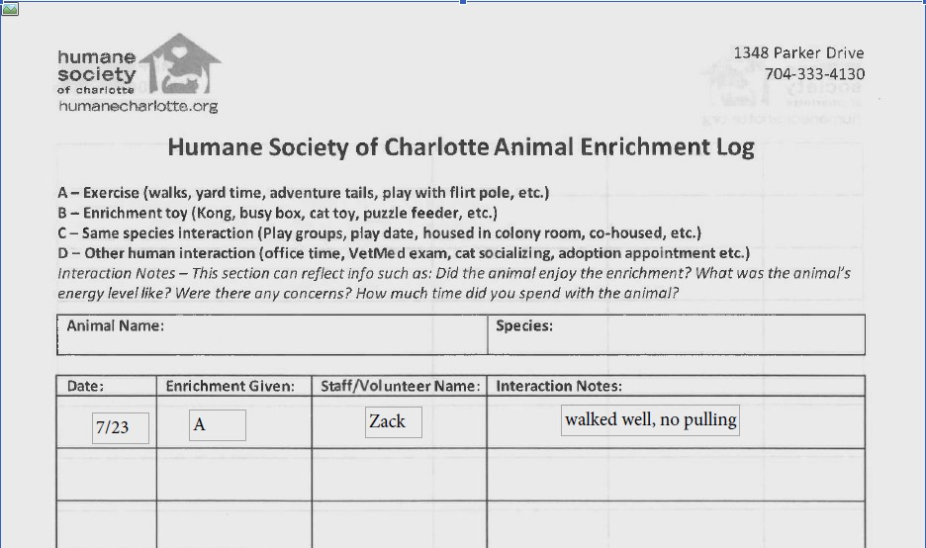

**General rules for taking a dog out of kennel suites:**

* No entering kennel suites. Exceptions: shy dogs/puppies (leave the door open or have a helper watch your back) and dogs refusing to go back in briefly step inside to unleash them. Please ask for permission if wanting to assist with socializing puppies or shy dogs.
* Use slip leads to leash dogs up (unless you feel absolutely comfortable using a clip leash)
* Not every dog is required to walk with a harness, check the binder to know
* Dogs that require a harness, use available enclosed areas (Play Yards 1 & 2).Do not use enclosed area that has the gate to the outside (Dog Walking In/Out as seen below).
* Dogs not requiring a harness need to be on a clip leash. Do not walk animals around with only a slip lead.
* If you are having trouble getting a dog in or out of a kennel successfully, please ask a staff member for assistance!
* Prepare dogs in a play yard prior to taking them out on the walk. This area will allow you safely transfer the dog from slip lead and into a harness. (preferred to do in play yard 1 as it prevents dog-to-dog contact if another walker is exiting through the door/gate near kennel 12)
* Use the door located near kennel 12 to take dogs out and walk on rear of the property or to HSC play yards (see image below). **Always make sure it is not in use before entering.**
* Please refrain from using your cell phone and headphones while walking the dogs.

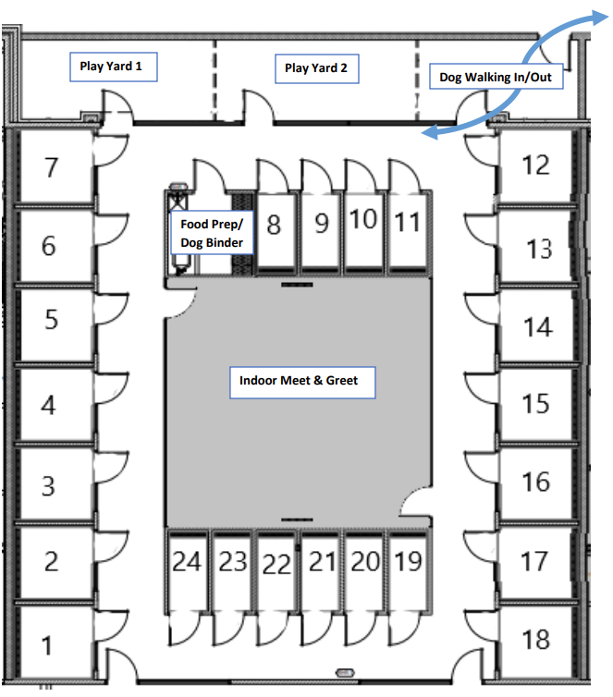

**Back of House Dogs**

Must check out the back-of-house hallway key from the volunteer office lockbox. (These keys are on the right side and numbered)

Please write down the Door Key # on the key log. Once you have the key you can start with Dog Intake (has a plaque that says Dog Holding 2) and walk ONLY the walk-approved dogs. You must go out and in using the hallway door that’s next to Dog Rehoming (has a plaque that says Dog ISO), opposite the side of Clinic Services. Once you finish with the dogs within Dog Intake, then you can move on to Rehoming (has a plaque that says Dog ISO) and finish with URI dogs that are walk approved**. Sometimes Dog ISO is STAFF ONLY/used for infectious quarantine purposes. Always pay attention to anything written on the door as it can change at any time.**

Always walk URI dogs that are walk-approved last and make sure to not take them on too long of a walk or let them run too much off leash as most of them are still in recovery from kennel cough. At times there are dogs housed in URI (has a plaque that says “Dog Holding 1”) that are not sick but are walk-approved. They are usually divided by a buffer and the non-sick dogs should always be walked first. Always use a new leash/harness with each dog as well and put the used leash/harness in the laundry room to be washed. We want to do our best to get these dogs out without spreading any diseases.

Once finished walking all walk-approved dogs in the back of house return the door key, 2-way radio, and HSC fanny pack. Then you can sign out by writing the return time on the key/fanny pack log.

**Designated Walking Areas and Duration**

There are several areas for dog walking, see the below map. Always use sidewalk paths to get to your desired areas unless it is over 80 degrees outside in which case you should aim for walking on the grass as much as possible to avoid paw burns. If you are walking on the back property beyond the tree line use the gravel walking path. Once over the bridge continue to take the gravel walk path to the cement pad and walk around the grassy area. Do not walk beyond the cement pad area. The two gated runs are open for you to use. The two runs are connected by a single entrance. Please make sure to only have one dog in the entrance at a time. If there is a dog in the other run you must prevent the dogs from interacting through the fence as much as possible to avoid fence fighting and disease spread. Make sure to have the radio with you and the volume on in case we need to call you back for an appointment or any other reason.

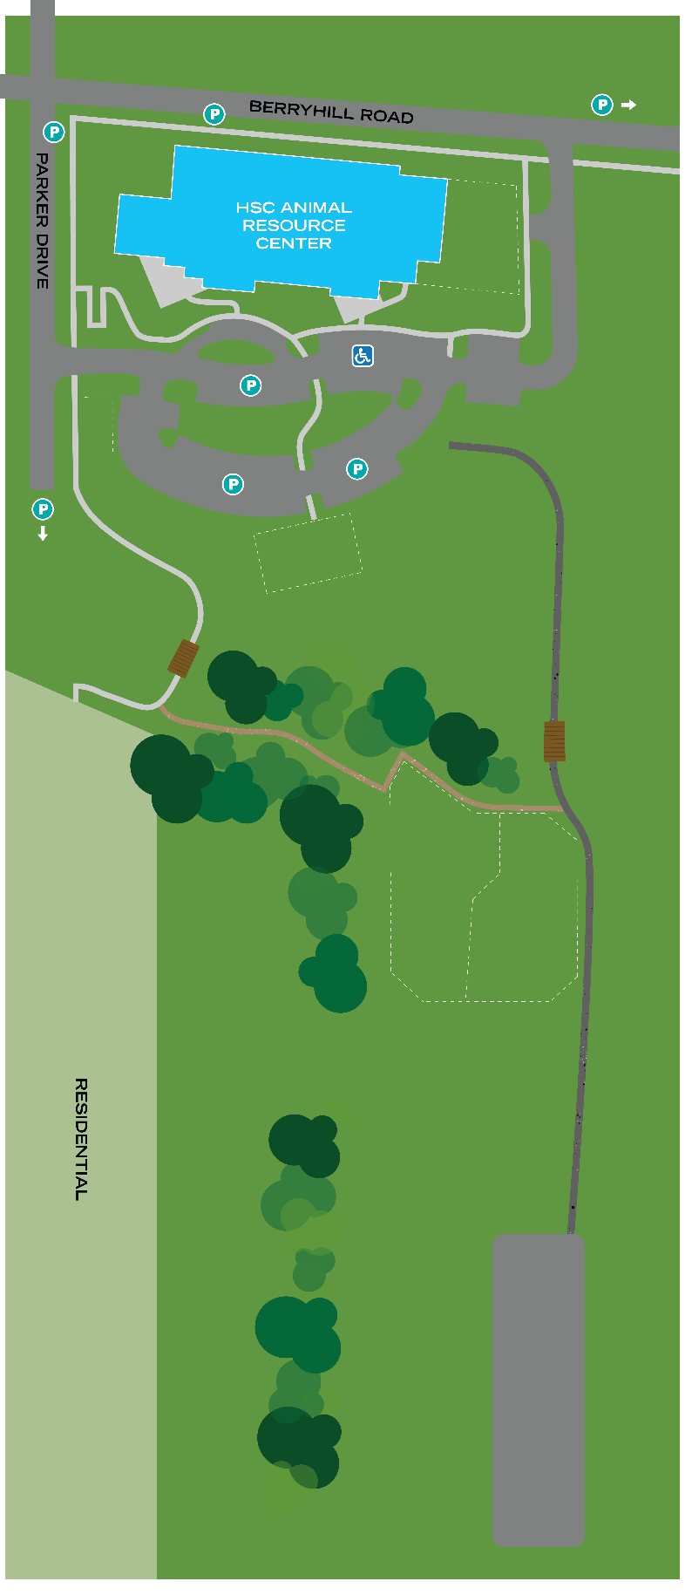

Small Play Yards

1-2

Play Yards

1-2

If your dog does not or cannot go on a long walk, you may take them into HSC’s designated fenced-in play yards located near the parking lot, see map above. Dogs that cannot go on long walks include dogs that are heartworm positive, dogs that have recently received heartworm treatment, dogs that were recently altered with cones, and other potential medical issues. Make sure to double-check the dog's kennel card to ensure there are no restrictions on walk length due to a special medical condition.

**On Leash Greeting**

As volunteers walk dogs during public hours, they may be approached by potential adopters and the general public to pet or interact with the dog they are walking. When we can, members of the public are allowed to interact with dogs on walks, however, to ensure animal and human safety, follow these guidelines;

* If the animal is unavailable for adoption, please do not allow members of the public to interact with the animal. Kindly tell the customer that the dog is not yet available for adoption but to keep an eye on the website if they are interested in interacting with the animal once it becomes available.
* If the animal has URI, refrain from allowing the public to interact with the animal. Explain that they have a cold that is contagious to the other animals on the property. If they are very interested in interacting, direct the potential adopter to speak to a Customer Service Rep to complete a survey and a staff member will facilitate a visit with the dog in ISO yard.
* Under no circumstances should you allow an HSC dog to interact with a public dog (on or off leash). If an adopter is interested in doing a meet and greet, please direct them to the front desk where an adoption counselor can assist with a dog-to-dog appointment if the dog is eligible.

**Behavior Concern Forms**

Behavior Concern forms can be filled out to notify our shelter behavior team of any worries surrounding an animal’s behavior. These forms can be found on the door of the Shelter Operations Manager’s office located in the Shelter Operations office suite. The form will ask you to name the animal and to briefly describe the incident/behavior that occurred. You are able to see the form in the picture below.

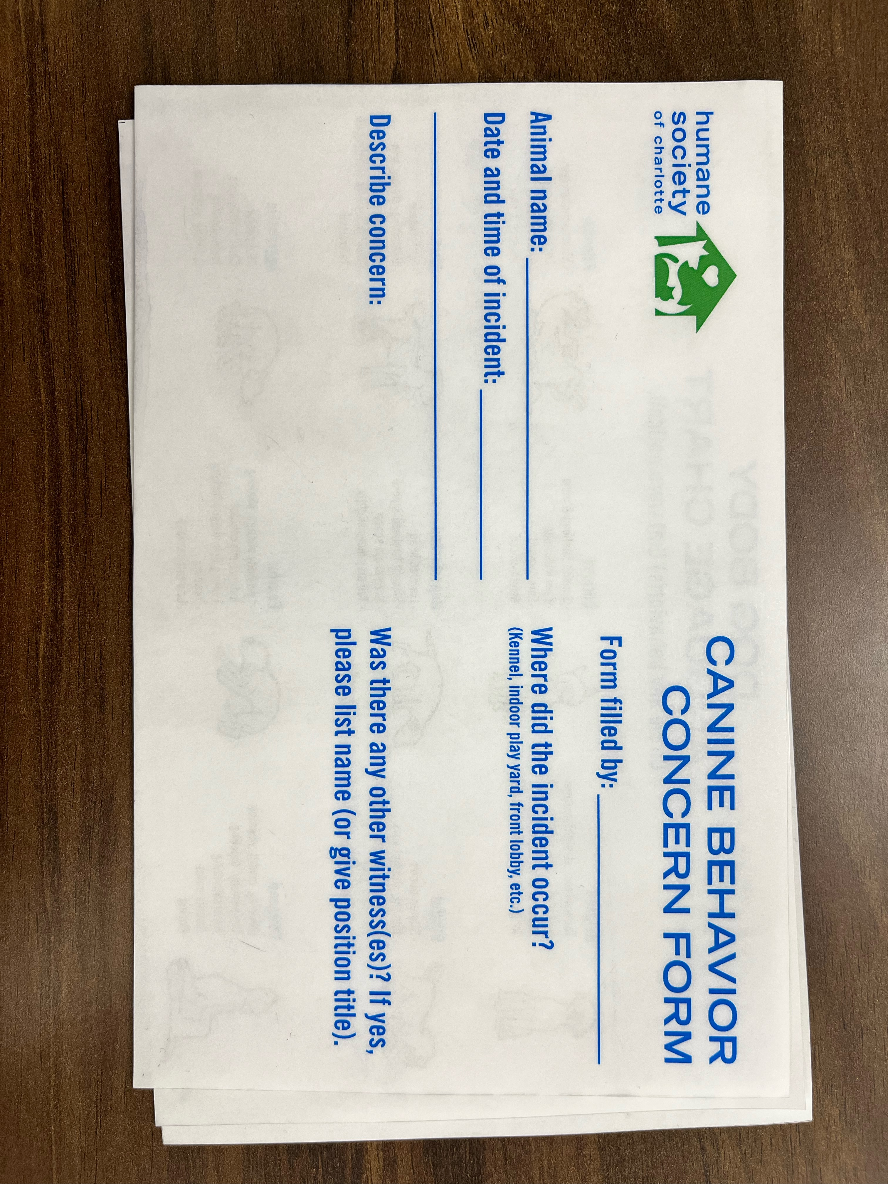

**Medical Concern Form**

When you have a concern about an animal’s health, please fill out a Medical Concern Form located in the wall pocket outside the treatment room. This form should be filled out as fully as possible but at a minimum must include animal’s name, reporter’s name, and a description of concern. Completed forms should be left in the wall pocket separate from clean forms. The members of the Shelter Vet Team will periodically check for Medical Concern Forms and address them as appropriate. An example can be seen in the picture below.

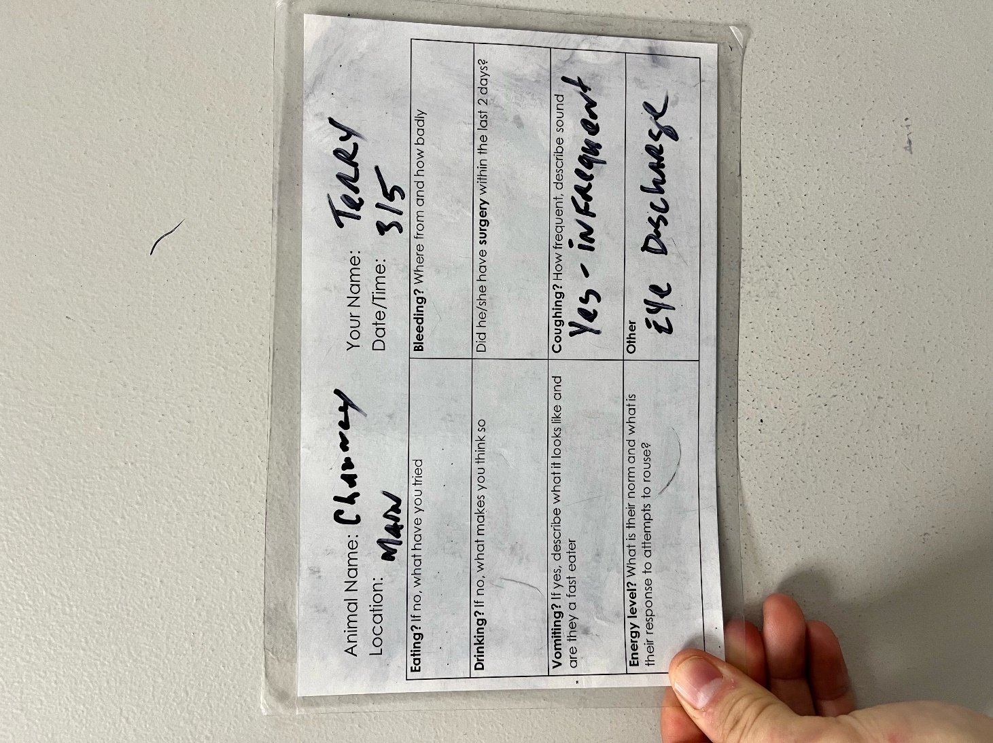

**Photos**

If you take photos or videos of dogs on walks you are welcome to share! Furthermore, please email them to the Volunteer Program Manager so that we can get them posted to our social media forums. [volunteer@humanecharlotte.org](mailto:volunteer@humanecharlotte.org). They can also be uploaded using the QR code below.

