Updated October 2022

Kennel cleaning guidelines:

Dog Holding 1&2

# Purpose

The kennel cleaning volunteer plays an integral role within the organization because they ensure that the dogs remain healthy and happy during their time at HSC. They provide a high level of humane care that prevents disease transmission, reduces the animal’s stress level and aids the intake process allowing the organization to assist more animals in need.

# What you will need

Before starting, check in the cabinets by the sink and make sure the following items are stocked/available in this area:

## Rescue spray bottle, Rescue foamer, dog blankets, dog hand towels, laundry basket, squeegee, long-handled scrub brush, broom and dust pan, poop scooper, gloves.

### Please ask a staff member to refill any empty Rescue spray bottles to their correct ratio.

### Blankets and towels can be found in laundry room.

# Before starting

## Take note of any kennel signage/notes.

### *STAFF ONLY* – these kennels should only be cleaned by staff members, not volunteers.

### *NC* (Not Clean) – these kennels require deep cleaning. (See Spot Cleaning vs. Deep Cleaning below)

### *Kennel Cards* – attached to kennel door; important medical and behavioral notes may be written here (see Example A below).

## **Alert a staff member immediately if a dog has removed their cone/e-collar, thrown up, has soft stool, appears lethargic, appears injured, or damaged their kennel.** Contingent on the situation, a staff member may have you fill out a medical concern form if not an emergency (see Example B below).

## **No animals should be directly handled (including puppies!). When situations arise where handling is necessary, please alert a staff member immediately.** This measure is to ensure the health and safety of our volunteers and animals by preventing disease spread and dangerous animal handling.

## In an effort to avoid confusion, please refrain from taking photos of dogs or puppies and posting them publicly. Many of the animals in these areas are not yet available to the public and cannot be shared on social media. Please do not violate this important media policy.

# Spot cleaning VS. Deep Cleaning

## *Spot cleaning* – daily cleaning of occupied kennels.

## *Deep cleaning* – the disinfecting of the entirety of a kennel before housing a new dog.

### See the Volunteer Checklist for step by step instructions on spot cleaning and deep cleaning.

# At the end of your shift

## Place dirty laundry baskets in the laundry room.

## If time permits, wash dishes and mop the floor. Ask a staff member for instruction, if needed.

## Let your assigned staff member know you have finished! Thank you!

# Example A – Kennel Card:

## Take note of any information on the kennel card that may be relevant to kennel cleaning. For example, the kennel card shown below notes that the dog is Heartworm Positive and not walk approved. Furthermore, you may see notes on the dog’s kennel door as seen in the following picture.

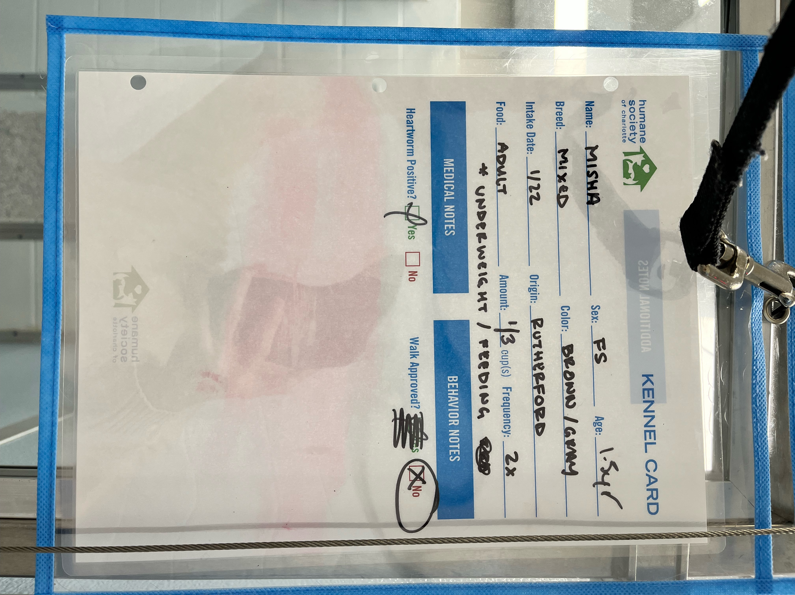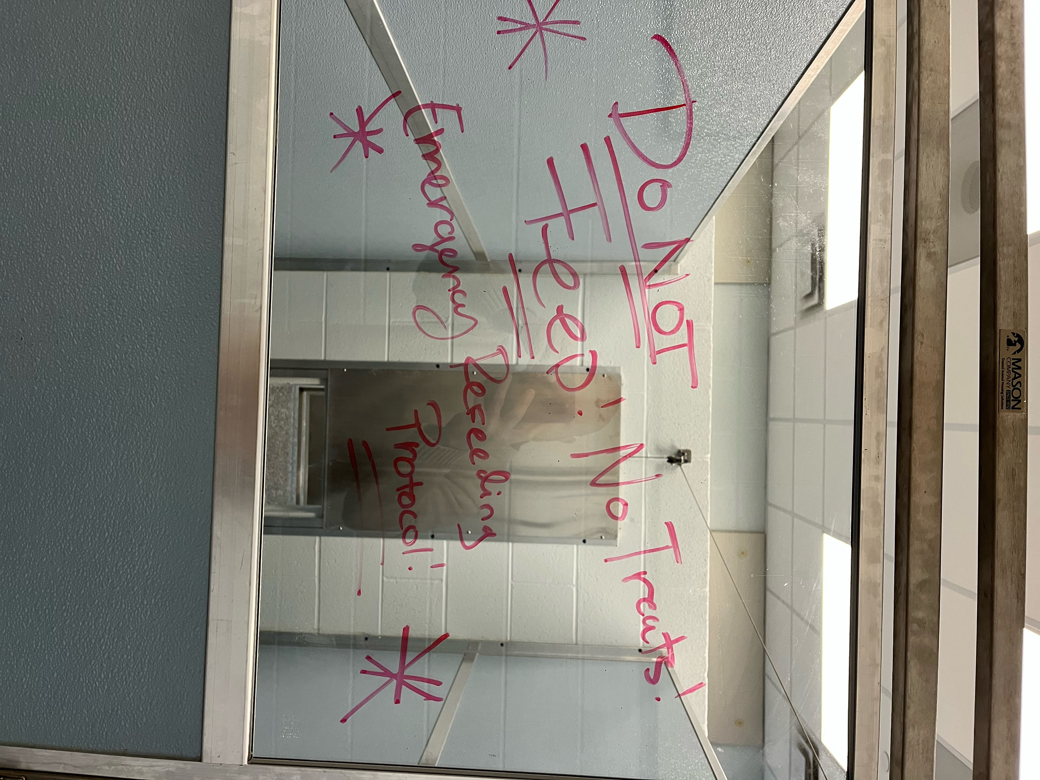

# Example B – Medical Concern Form

## Please fill out a medical concern form like the one below if the situation is deemed non-emergent by a staff member. Medical concern forms are located by the treatment room. If unsure how, ask a staff member for assistance.

# cid:c57fe13b-6169-48fb-91e2-c333b4da85cf@namprd13.prod.outlook.com