How to Add Qualifications

\*using the example of Olivia’s dog training volunteers

1. Using Oliva’s email, you will go into each volunteer’s profile and add the “approved for dog training training classes qualification”

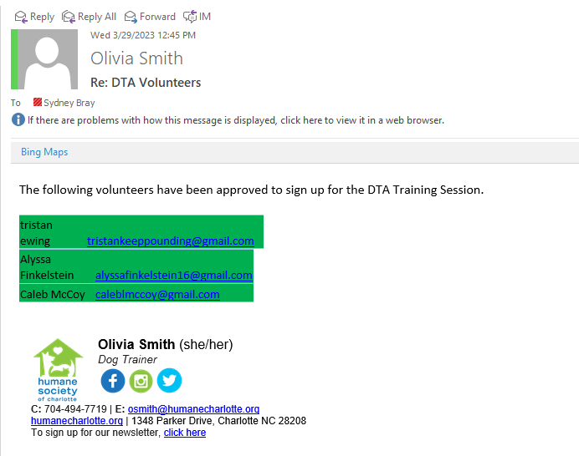

2. Open Galaxy Digital and click the “User” tab on the left of the screen

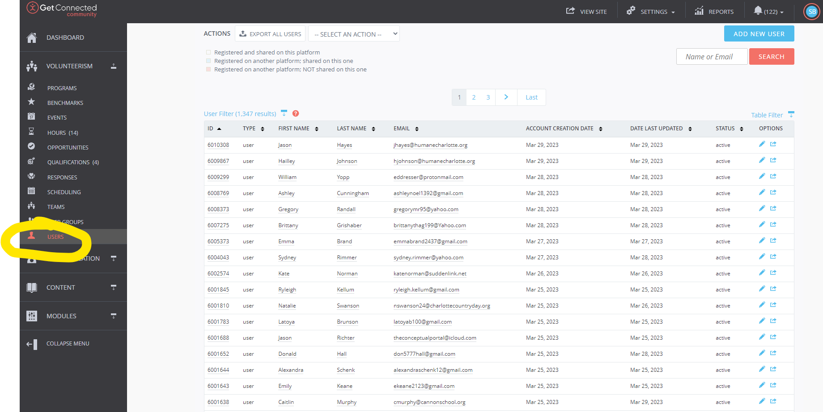

3. Copy and paste the name or email of the volunteer into the search bar

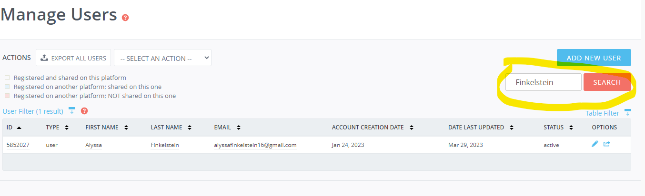

4. Click on the user’s first or last name to open their profile. Then, click on the “Qualifications” tab

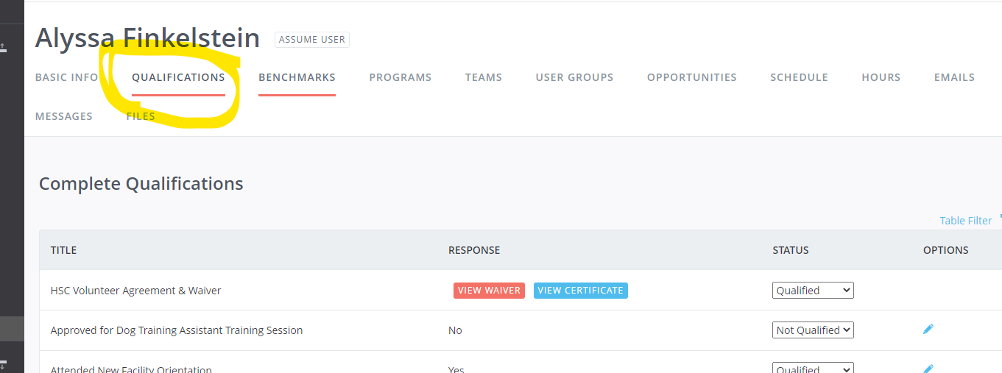

5. Click the “Yes” Circle by the first question.

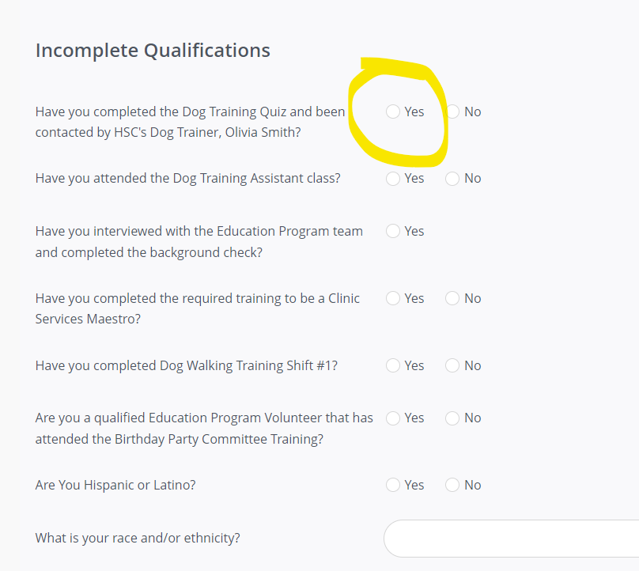

6. Scroll down and select “Submit Qualifications.”

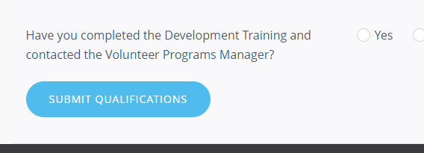

Note: This process is the same for any qualification that you need to add.